Support Information

OSMAC-Activated Alkaloid Diversity in a Mangrove Aspergillus sp. PLP1-F1 Drives Host-Directed Antibacterial Mechanisms

Fendi Setiawan ^{1,a}*⁾; Wawan A. Setiawan ^{2,b}; Rudy T. M. Situmeang ^{3,c}; Yuli Ambarwati ^{3,d}; Ni Luh Gede Ratna Juliasih ^{3,e}; Susianti Susianti ^{4.f};
Peni Ahmadi ^{5,g}; Masayoshi Arai ^{6,h}; Andi Setiawan ^{3,i}*⁾

¹Doctoral Program, Lampung University, Bandar Lampung-35145 (Indonesia)
²Department of Biology, Lampung University, Bandar Lampung-35145 (Indonesia)
³ Department of Chemistry, Lampung University, Bandar Lampung-35145 (Indonesia)
⁴Department of Pathology, Histology and Anatomy, Lampung University, Bandar Lampung-35145 (Indonesia)
⁵Research Center for Vaccine and Drugs, National Research and Innovation Agency Republic of Indonesia, Cibinong-16911 (Indonesia)
⁶Graduate School of Pharmaceutical Sciences, Osaka University, Osaka-5650871 (Japan)
Correspondence: a*) fendi.setiawan2005@students.unila.ac.id
^{b)} wawan.as@fmipa.unila.ac.id
^{c)} rudy.tahan@fmipa.unila.ac.id
^{d)} yuli.ambarwati@fmipa.unila.ac.id
^{e)} niluhratna.juliasih@fmipa.unila.ac.id
^{f)} susianti.1978@fk.unila.ac.id
^{g)} peni.ahmadi@brin.go.id
^{h)} araim@phs.osaka-u.ac.jp
^{i*)} andi.setiawan@fmipa.unila.ac.id

ORCIDs:
First AUTHOR : https://orcid.org/0000-0003-1006-5150
Second AUTHOR : https://orcid.org/0000-0002-6448-3959
Third AUTHOR : https://orcid.org/0000-0001-6622-0362
Fourth AUTHOR : https://orcid.org/0000-0002-6738-709X
Fifth AUTHOR : https://orcid.org/0000-0002-6202-461X
Sixth AUTHOR : https://orcid.org/0000-0002-5458-0915
Seventh AUTHOR : https://orcid.org/0000-0003-0865-3420
Eighth AUTHOR : https://orcid.org/0000-0003-2771-1948
Ninth AUTHOR : https://orcid.org/0000-0002-0731-6417

ACKNOWLEDGEMENT

This research was supported by the Higher Education Technology Innovation Lampung University (HETI UNILA), Asian Development Bank, Directorate General of Higher Education, Research and Technology, the Ministry of Education, Culture, Research and Technology, Republic of Indonesia, for the Innovation Research Scheme and Domestic Cooperation award with a grant number of 11757/UN26/HK.01.03/2025. The authors also thank Technical Service Unit, Integrated Laboratory (UPA-LT), Lampung University. The first author would like to express deepest gratitude to the late Prof. John Hendri, Ph.D. for his invaluable guidance, support, and mentorship, which greatly shaped the author’s academic and research journey.

AUTHOR CONTRIBUTIONS

Conceptualization, Writing Original Draft Preparation, A. S., F. S.; Software, Visualization, F. S.; Validation, N. L. G. R. J., P. A., S. S.; Methodology, Formal Analysis, Investigation, Data Curation, F. S, P. A.; Resources, A.S.; Writing Review & Editing, M. A., P. A.; Supervision, A.S., R.T.M.S., Y.A.; Project Administration, N. L. G. R. J., D. M. S., W. W; Funding Acquisition, A. S., S. S., N. L. G. R.

CONFLICT OF INTEREST

The authors declare no conflict of interest.

DECLARATION OF GENERATIVE AI AND AI-ASSISTED TECHNOLOGIES IN THE MANUSCRIPT PREPARATION

During the preparation of this work the authors used Microsoft Copilot to assist in language editing, structuring, and improving clarity of the manuscript. After using this tool, the authors reviewed and edited the content as needed and took full responsibility for the content of the publication.

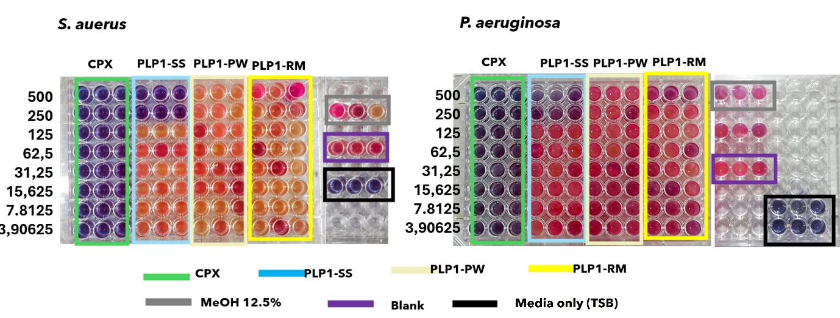
Figure S1. MIC anlaysis; (a) MDR S. aurues; and (b) P. aeruginosa.

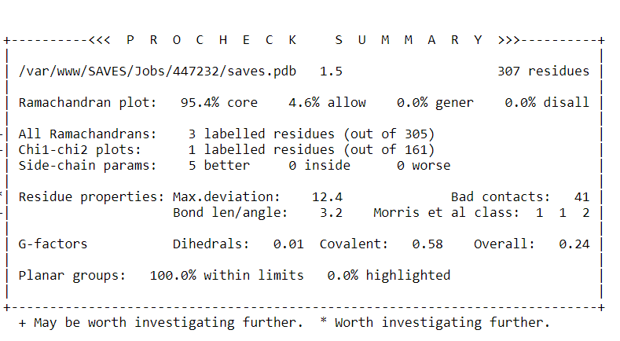
Figure S2. PROCHECK evaluation of FtsZ receptor (3VOA)

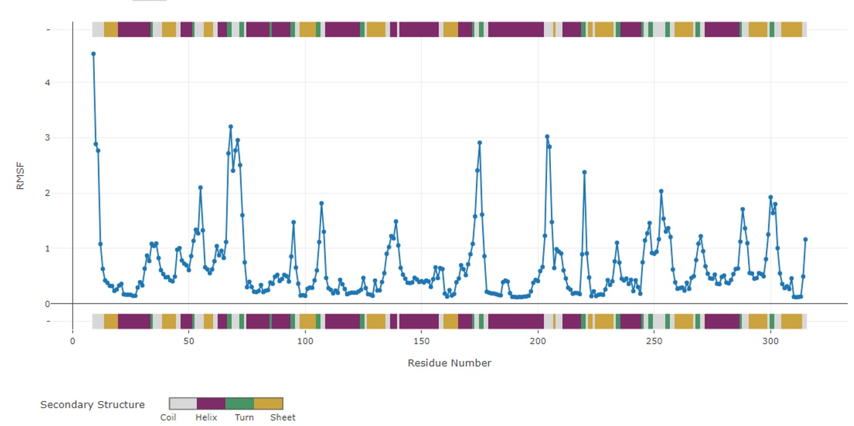

Figure S3. RMSF analysis of 3VOA before docking analysis

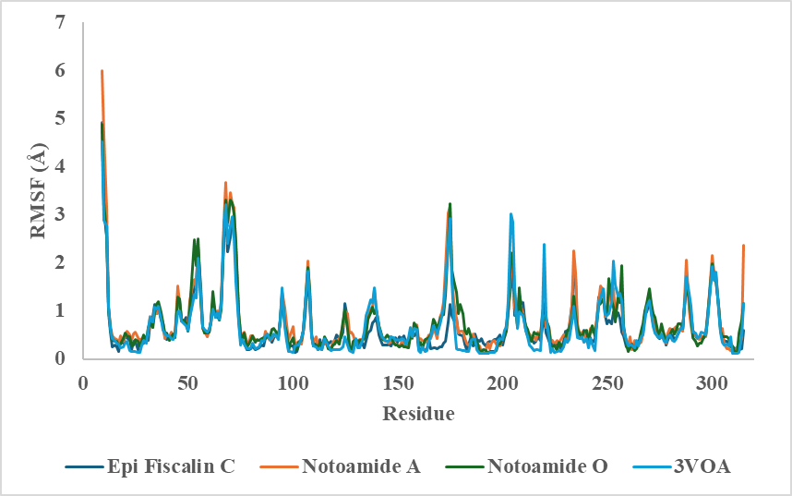

Figure S4. RMSF analysis compounds 16, 20, 21 with 3VOA after docking analysis

Table S1. Biological process, celullar component, Molecular function analysis
Category | Description | FDR Value
GO Biological Process | Response to oxygen-containing compound | 7.1E-17
GO Biological Process | Apoptotic process | 8.4E-17
GO Biological Process | Cell death | 1.0E-16
GO Biological Process | Programmed cell death | 1.0E-16
GO Biological Process | Cellular response to chemical stress | 1.2E-16
GO Biological Process | Response to chemical | 3.0E-16
GO Biological Process | Positive regulation of response to stimulus | 4.0E-16
GO Biological Process | Response to stress | 5.2E-16
GO Biological Process | Response to nitrogen compound | 7.0E-16
GO Biological Process | Response to abiotic stimulus | 1.3E-15
GO Biological Process | Positive regulation of cell communication | 1.3E-15
GO Biological Process | Positive regulation of signaling | 1.3E-15
GO Biological Process | Cellular response to oxygen-containing compound | 3.4E-15
GO Biological Process | Protein phosphorylation | 7.2E-15
GO Biological Process | Regulation of intracellular signal transduction | 1.1E-14
GO Biological Process | Regulation of apoptotic process | 1.3E-14
GO Biological Process | Cell migration | 1.7E-14
GO Biological Process | Cell motility | 1.7E-14
GO Biological Process | Phosphorylation | 2.0E-14
GO Biological Process | Regulation of programmed cell death | 2.0E-14
GO Celullar Component | Perinuclear region of cytoplasm | 6.3E-08
GO Celullar Component | Plasma membrane bounded cell projection | 6.3E-08
GO Celullar Component | Cell projection | 9.3E-08
GO Celullar Component | Membrane raft | 7.6E-07
GO Celullar Component | Membrane microdomain | 7.6E-07
GO Celullar Component | Dendritic tree | 7.7E-07
GO Celullar Component | Somatodendritic compartment | 8.6E-07
GO Celullar Component | Cytoplasmic vesicle | 2.2E-06
GO Celullar Component | Cell body | 2.2E-06
GO Celullar Component | Intracellular vesicle | 2.2E-06
GO Celullar Component | Caveola | 4.1E-06
GO Celullar Component | Mitochondrion | 4.4E-06
GO Celullar Component | Dendritic growth cone | 4.4E-06
GO Celullar Component | Dendrite | 4.6E-06
GO Celullar Component | Neuronal cell body | 7.5E-06
GO Celullar Component | Dendrite terminus | 1.4E-05
GO Celullar Component | Plasma membrane raft | 1.4E-05
GO Celullar Component | External encapsulating structure | 1.8E-05
GO Celullar Component | Extracellular matrix | 1.8E-05
GO Celullar Component | Vesicle | 2.0E-05
GO Molecular Function | Catalytic activity acting on a protein | 3.2E-15
GO Molecular Function | Protein kinase activity | 9.0E-12
GO Molecular Function | Phosphotransferase activity alcohol group as acceptor | 5.8E-11
GO Molecular Function | Enzyme binding | 9.0E-11
GO Molecular Function | Kinase activity | 1.5E-10
GO Molecular Function | Transferase activity transferring phosphorus-containing groups | 1.8E-09
GO Molecular Function | ATP binding | 7.7E-09
GO Molecular Function | Adenyl ribonucleotide binding | 1.0E-08
GO Molecular Function | Endopeptidase activity | 1.7E-08
GO Molecular Function | Adenyl nucleotide binding | 1.8E-08
GO Molecular Function | Protein tyrosine kinase activity | 7.3E-08
GO Molecular Function | Purine ribonucleoside triphosphate binding | 9.1E-08
GO Molecular Function | Tau protein binding | 1.1E-07
GO Molecular Function | Purine ribonucleotide binding | 1.1E-07
GO Molecular Function | Ribonucleotide binding | 1.2E-07
GO Molecular Function | Carbohydrate derivative binding | 1.5E-07
GO Molecular Function | Purine nucleotide binding | 1.8E-07
GO Molecular Function | Protein serine/threonine kinase activity | 2.1E-07
GO Molecular Function | Serine-type endopeptidase activity | 2.6E-07
GO Molecular Function | Peptidase activity | 4.1E-07

