Support Information
Synthesis, Structural, Spectroscopic, and DFT Characterization of a Thermodynamically Stable Bis(quercetin)copper(II) Complex and Its α-Amylase Inhibitory Activity

Puteri Khansa Salsabila ^{1,a)}; Yusi Deawati ^{1,b)}; Regaputra Satria Janitra ^{1,c)}; Safri Ishmayana ^{1,d)}; Iman Permana Maksum ^{1,e)}; Yessi Permana ^{2,f)}; Yudha Prawira Budiman ^{1,g)}

¹Department of Chemistry, Padjadjaran University, Sumedang-45363 (Indonesia)
² Division of Inorganic and Physical Chemistry, Institut Teknologi Bandung, Bandung-40132 (Indonesia)

^{a)}puteri19001@mail.unpad.ac.id
^{b)}yusi.deawati@unpad.ac.id
^{c)}regaputra15001@mail.unpad.ac.id
^{d)}ishmayana@unpad.ac.id
^{e)}iman.permana@unpad.ac.id
^{f)}yessi@itb.ac.id
^{g)}Correspondence: y.p.budiman@unpad.ac.id

ORCIDs:
First AUTHOR : https://orcid.org/0009-0005-0455-0469
Second AUTHOR : https://orcid.org/0000-0002-4561-8715
Third AUTHOR : https://orcid.org/0000-0003-2073-8849
Fourth AUTHOR : https://orcid.org/0000-0002-9825-4425
Fifth AUTHOR : https://orcid.org/0000-0001-8166-8421
Sixth AUTHOR : https://orcid.org/0000-0002-1553-7105
Seventh AUTHOR : https://orcid.org/0000-0002-3929-1891

ACKNOWLEDGEMENT

Y. P. B. acknowledges financial support from Universitas Padjadjaran for a Competency Research Grant for Lecturers at Universitas Padjadjaran (RKDU, 2025). Y. D. acknowledges the Directorate General of Higher Education, the Ministry of Research and Technology of Indonesian Republic, for the PFR research fund (contract number: 148/E5/PG.02.00.PL/2023 in June 19th, 2023) and the Universitas Padjadjaran for the Academic Leadership Grant in 2023 (contract number: 1549/UN6.3.1/PT.00/2023 in March 27th, 2023) as a financial support provider for the continuation of this research.

AUTHOR CONTRIBUTIONS

Conceptualization, P. K. S., Y. D., and Y. P. B.; Methodology, P. K. S., Y. D., R. S. J., Y. P. B., and S. I.; Software, R. S. J.; Validation, Y. D., Y. P. B., S. I., I. P. M., and Y. P.; Formal Analysis, P. K. S., Y. D., R. S. J., and Y. P. B.; Investigation, P. K. S., Y. D., and R. S. J.; Resources, Y. D. and S. I.; Data Curation, P. K. S., Y. D., and R. S. J.; Writing – Original Draft Preparation, P. K. S., Y. D., R. S. J., and Y. P. B.; Writing – Review & Editing, P. K. S., Y. D., R. S. J., Y. P. B., and Y. P.; Visualization, P. K. S. and R. S. J.; Supervision, Y. D., Y. P. B., S. I., I. P. M., and Y. P.; Project Administration, Y. D. and Y. P. B.; Funding Acquisition, I. P. M. and Y. P. B.

CONFLICT OF INTEREST

The authors declare no conflict of interest.

DECLARATION OF GENERATIVE AI AND AI-ASSISTED TECHNOLOGIES IN THE MANUSCRIPT PREPARATION

AI was not involved in the generation or manipulation of scientific data, figures, results, or conclusions.

FIGURE
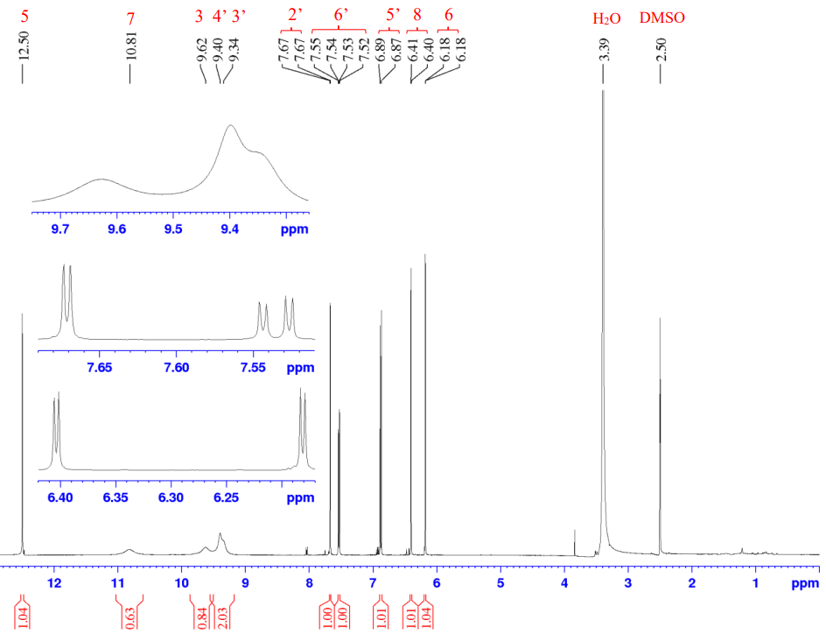
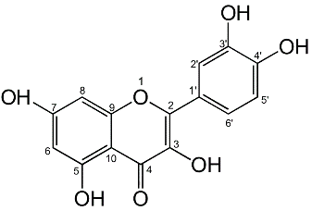
¹H-NMR of Quercetin
Figure S1. ¹H-NMR spectrum (DMSO-d₆/TMS, 500 MHz) of quercetin

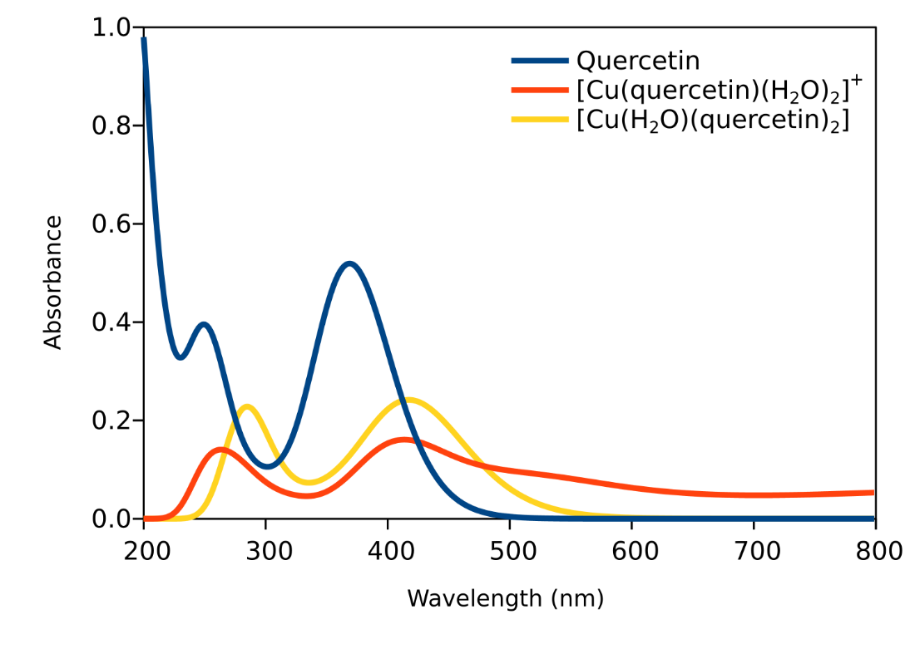
DFT Computational Results
Figure S2. UV–Vis spectra of quercetin, [Cu(Q)(H₂O)₂]⁺, and [Cu(H₂O)(Q)₂] in ethanol calculated at the SMD-TD-M06/def2-SVP//M06/def2-SVP level of theory
Figure S3. The optimized structure of quercetin at the M06/def2-TZVP level of theory
Figure S4. Visualization of the charge distribution on quercetin. The color scheme used is red–
black–green, where red indicates negative charge, black indicates neutral, and green indicates positive charge. The blue arrow represents the dipole moment vector following the physics convention (mathematical vector pointing toward the positive charge
TABLE
Table S1. Comparison of DFT-Calculated and Experimental λ_{max} Values for Quercetin and Copper–Quercetin Complexes
 | λ_{max} / nm
 | Calculated | Experiment
Quercetin | 258.89 (Band II) | 257
 | 369.44 (Band I) | 372
[Cu(quercetin)(H₂O)₂]⁺ | 279.21 (Band II) | -
 | 409.71 (Band I) | -
[Cu(H₂O)(quercetin)₂] | 282.60 (Band II) | 271
 | 423.72 (Band I) | 427
Table S2. The charge distribution of the oxygen atoms in quercetin in methanol at the SMD- M06/def2-TZVP//M06/def2-TZVP level of theory
Atom | Charge
Atom | Mulliken Population Analysis (MPA) | Natural Population Analysis (NPA) | Hirshfeld Population Analysis (HPA) | CM5 Population Analysis (CM5)
10O | -0.40 | -0.41 | -0.09 | -0.16
17O | -0.51 | -0.67 | -0.23 | -0.42
18O | -0.52 | -0.68 | -0.21 | -0.41
19O | -0.53 | -0.68 | -0.23 | -0.43
20O | -0.66 | -0.71 | -0.31 | -0.38
21O | -0.52 | -0.67 | -0.21 | -0.41
22O | -0.56 | -0.69 | -0.20 | -0.41

Table S3. The atomic orbital contributions to the HOMO and LUMO of quercetin in methanol at the SMD-M06/def2-TZVP//M06/def2-TZVP level of theory
HOMO | LUMO
C8-p=0.15 | C7-p=0.20
C14-p=0.10 | C9-p=0.16
C12-p=0.08 | O20-p=0.10
O18-p=0.08 | C14-p=0.07
C11-p=0.07 | C3-p=0.06
C9-p=0.07 | C16-p=0.06
C6-p=0.06 | C12-p=0.05
O22-p=0.06 | C1-p=0.05
C15-p=0.05 | O10-p=0.04
O19-p=0.03 | C8-p=0.03
C3-p=0.03 | C11-p=0.02
C1-p=0.02 | C5-p=0.02
O20-p=0.02 | C8-d=0.02
O17-p=0.02 | O17-p=0.01
C4-p=0.02 | O22-p=0.01
O10-p=0.02 | C4-d=0.01
C13-p=0.02 | O21-p=0.01
O21-p=0.01
C7-p=0.01

Table S4. The charge distribution of the polar hydrogen atoms (on the –OH groups) in quercetin in methanol at the SMD-M06/def2-TZVP//M06/def2-TZVP level of theory
Atom | Charge
Atom | Mulliken Population Analysis (MPA) | Natural Population Analysis (NPA) | Hirshfeld Population Analysis (HPA) | CM5 Population Analysis (CM5)
28H | 0.38 | 0.52 | 0.15 | 0.34
29H | 0.38 | 0.52 | 0.17 | 0.36
30H | 0.39 | 0.52 | 0.19 | 0.38
31H | 0.40 | 0.52 | 0.22 | 0.40
32H | 0.40 | 0.52 | 0.22 | 0.40

Table S5. The Wiberg bond index (WBI) of the –OH groups in quercetin in methanol at the SMD-M06/def2-TZVP//M06/def2-TZVP level of theory
Bond | Bond Order (WBI)
17O-28H | 0.65
18O-29H | 0.69
19O-30H | 0.71
21O-31H | 0.72
22O-32H | 0.71

Table S6. The O–Cu bond distances (Å) in the [Cu(Q)(H₂O)₂]⁺ complex
[Cu(Q)(H₂O)₂]⁺ | H₂O |  |  | Quercetin⁻
[Cu(Q)(H₂O)₂]⁺ | O33-Cu | O36-Cu | Average | O18-Cu | O20-Cu | Average
[Cu(Q)(H₂O)₂]⁺ | 2.02 | 2.18 | 2.10 | 1.95 | 2.25 | 2.10

Table S7. The O–Cu bond distances (Å) in the [Cu(H₂O)(quercetin)₂] complex
[Cu(H₂O)(Q)₂] | H₂O |  | Quercetin⁻
[Cu(H₂O)(Q)₂] | O46-Cu | Average | O12-Cu | O14-Cu | O23-Cu | O24-Cu | Average
[Cu(H₂O)(Q)₂] | 2.35 | 2.35 | 2.00 | 1.95 | 1.91 | 1.99 | 1.96

Table S8. The Wiberg bond index (WBI) of the O–Cu in the [Cu(quercetin)(H₂O)₂]⁺ complex
[Cu(Q)(H₂O)₂]⁺ | H₂O |  | Quercetin⁻
[Cu(Q)(H₂O)₂]⁺ | O33-Cu | O36-Cu | O18-Cu | O20-Cu
[Cu(Q)(H₂O)₂]⁺ | 0.19 | 0.13 | 0.26 | 0.11

Table S9. The Wiberg bond index (WBI) of the O–Cu in the [Cu(H₂O)(Q)₂] complex
[Cu(H₂O)(Q)₂] | H₂O | Quercetin-
[Cu(H₂O)(Q)₂] | O46-Cu | O12-Cu | O14-Cu | O23-Cu | O24-Cu
[Cu(H₂O)(Q)₂] | 0.12 | 0.25 | 0.30 | 0.32 | 0.25

